

CP Lab-06 Tasks

Name: Syed Muhammad Raza Ali

Enrolment: 02-134231-028

Course: CP Lab

Faculty: Miss Fatima

**Lab 06 Multiple Arrays**

**Tasks: 01**

Write a program to create a 2D array of size 3x3. The program takes input for each cell in the array and then calculates and displays the sum of each row.

Code:

#include <iOStream>

using namespace std;

int main() {

int arr[3][3];

int sum = 0;

for (int i = 0; i < 3; i++) {

for (int j = 0; j < 3; j++) {

cout << "Enter the value of index no : " << i << j<<endl;

cin >> arr[i][j];

}

}

cout << "----------------------------------" << endl;

cout << "Your array is " << endl;

for (int i = 0; i < 3;i++) {

for (int j = 0; j < 3; j++) {

cout << arr[i][j] << " ";

}

cout << endl;

}

cout << "----------------------------------"<<endl;

for (int i = 0; i < 3; i++)

{

for (int j = 0; j < 3; j++)

{

sum = sum + arr[i][j];

}

cout << "The sum of row " << i << " = " << sum << endl;

sum = 0;

}

}

Output:

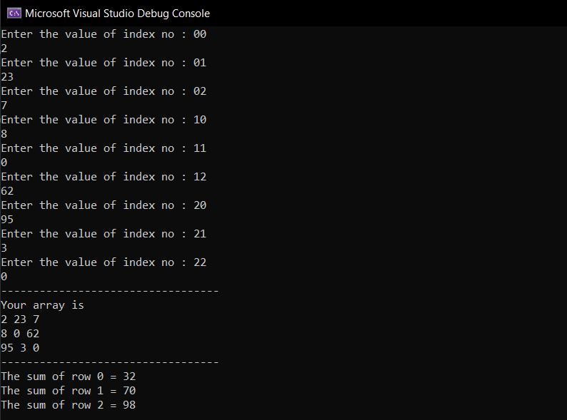

**Tasks: 02**

Write a program that takes a 3x3 matrix as input and asks for a number entered and prints out its position in the matrix. It displays not found if the number is not in the matrix.

Code:

#include <iOStream>

using namespace std;

int main() {

int arr[3][3];

for (int i = 0; i < 3; i++) {

for (int j = 0; j < 3; j++) {

cout << "Enter the value of position " << i << j << endl;

cin >> arr[i][j];

}

}

cout << "Your array " << endl;

for (int i = 0; i < 3; i++) {

for (int j = 0; j < 3; j++) {

cout << arr[i][j] << " ";

}

cout << endl;

}

cout << "------------------------------------------------" << endl;

int searchElement;

cout << "Enter the Element you want to search" << endl;

cin >> searchElement;

bool flag = false;

for (int i = 0; i < 3; i++) {

for (int j = 0; j < 3; j++) {

if (arr[i][j] == searchElement) {

cout << "Element found at Position : " << i << j<<endl;

flag = true;

}

}

}

if (flag == false) {

cout << "Element doesnt exist" << endl;

}

return 0;

}

Output (if the value exists):

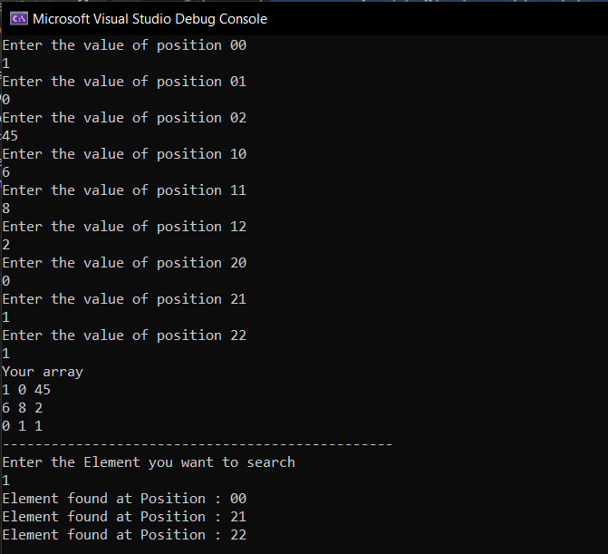

Output (if the value doesn’t exist):

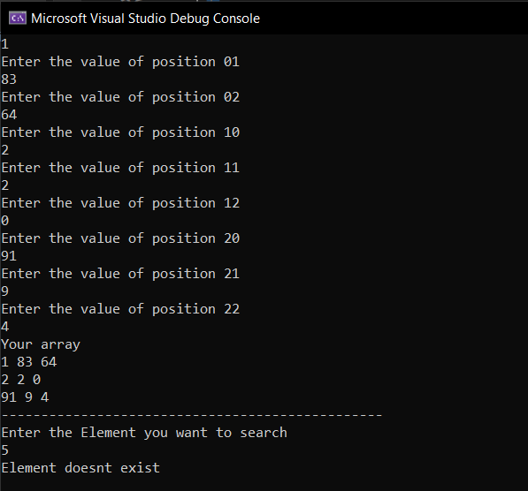

**Tasks: 03**

Write a program which calculates the transpose of a 3x3 matrix.

Code:

#include <iOStream>

using namespace std;

int main() {

int arr[3][3];

for (int i = 0; i < 3; i++) {

for (int j = 0; j < 3; j++) {

cout << "Enter the value of position " << i << j << endl;

cin >> arr[i][j];

}

}

cout <<endl<< "Your array " << endl;

for (int i = 0; i < 3; i++) {

for (int j = 0; j < 3; j++) {

cout << arr[i][j] << " ";

}

cout << endl;

}

cout << endl << "Transpose of the entered array is " << endl;

for (int i = 0; i < 3; i++) {

for (int j = 0; j < 3; j++) {

cout << arr[j][i]<<" ";

}

cout << endl;

}

return 0;

}

Output:

